

**Tribhuvan University**

**Faculty of Humanities and Social Sciences**

# Hand Gesture Detection

**A PROJECT PROPOSAL**

**Submitted to**

**Department of Computer Application**

**Kathmandu college of central state**

solteemode, Kathmandu

***In partial fulfillment of the requirements for the Bachelor in Computer Application***

**Submitted by**

**Shiksha Basnet and Shriya Karki**

BCA 8th Semester

Under the Supervision of

**Santosh Baral**

Table of Content

**1.** **INTRODUCTION** 1

**2. PROBLEM STATEMENT** 1

**3. OBJECTIVES** 2

**4. METHODOLOGY** 2

**4.1. REQUIREMENT IDENTIFICATION** 3

**4.1.1. STUDY OF EXISTING SYSTEM** 3

**4.1.2. LITERATURE REVIEW** 3

**4.2. FEASIBILITY STUDY** 5

**4.2.1. TECHNICAL FEASIBILITY** 5

**4.2.2. ECONOMIC FEASIBILITY** 5

**4.2.3. OPERATIONAL FEASIBILITY** 5

**4.3. FLOW CHART** 6

**5.GANTT CHART** 7

**6. Expected Outcomes** 7

**Reference**

# 1.INTRODUCTION

Sign language is the most significant way of communication between the impaired people. Establishing an easy way of communication with deaf and dumb people is very important. Everyone should be able to understand sign language as it would be useful in case of any emergency. These individuals communicate through hand signals or gestures.

The gesture is a vital and meaningful mode of communication for the visually impaired person. So here is the computer-based method for regular people to understand what the differently abled individual is trying to say. In our system, the user will perform the hand gestures or signs by turning on their camera, and the system will detect the sign and display it to the user.

In this sign language detection system, a sign detector detects numbers, which can be easily extended to cover a wide range of other signs and hand signs, including the alphabet. In this system, we are using a machine learning model known as CNN. Convolutional Neural Networks (CNNs) can learn complicated objects and patterns because they have an input layer, an output layer, numerous hidden layers, and millions of parameters.

By turning on the camera, the user can perform the hand signs, and the system will detect the sign and display it to the user. Using hand signs, the individual may send out more information in a shorter amount of time.

# 2. PROBLEM STATEMENT

The desire for a computer-based solution is significant in this age of technology for deaf people. However, researchers have been working on the problem for quite some time, and the results are promising. Although interesting technologies for voice recognition are becoming available, there is currently no commercial solution for sign detection on the market.

In our system, the user will perform the hand gestures or signs by turning on their camera, and the system will detect the sign and display it to the user.

# 3. OBJECTIVES

The Sign Language Detection Prototype is a real-time vision-based system whose purpose is to recognize the American Sign Language given in the alphabet.

The objectives of this systems are:

• To detect hand sign

# 4. METHODOLOGY

The waterfall model is a classical model used in the system development life cycle to create a system with a linear and sequential approach. It is termed a waterfall because the model develops systematically from one phase to another in a downward fashion. The waterfall approach does not define the process to go back to the previous phase to handle changes in requirements. The waterfall approach is the earliest approach that was used for software development.

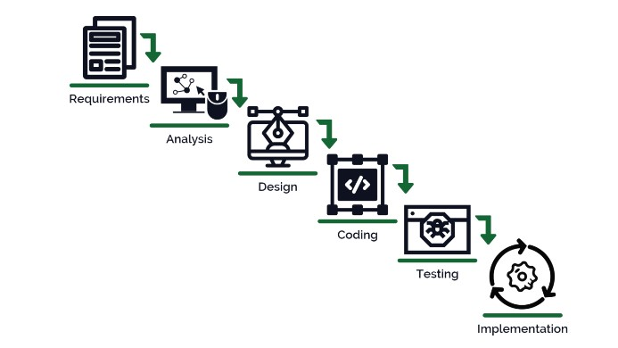

Fig 1-Waterfall model

## 4.1. REQUIREMENT IDENTIFICATION

### 4.1.1. STUDY OF EXISTING SYSTEM

A Hand Gesture Sign Language to Text Real Time Interpreter using Google Mediapipe Artificial Intelligence by Riaz Sulaimi on 2022 which aimed at innovating a device to help those without the knowledge of sign language to communicate with this group of people.[1]

HandSign - Learn a Sign Language with Your Camera by Syauqy Nurul Aziz is an application. HandSign is a real-time sign language translator that detects your hand pose and translate it into the American Sign Language letter or alphabet.[2]

### 4.1.2. LITERATURE REVIEW

Hand sign detection is a rapidly growing field in computer vision and human-computer interaction. It involves the recognition of hand gestures and signs, which can be used in various applications, such as sign language translation, virtual reality, and gaming. In this literature review, we will explore some of the recent research in this field and how it relates to the proposed research in hand sign detection.

Rule-based methods: Rule-based methods use predefined rules to recognize hand signs. These rules are typically based on the position and orientation of the hand, as well as the shape and movement of the fingers. For example, the Viola-Jones algorithm is a popular rule-based method that uses Haar-like features to detect faces and hands in images.

Feature-based methods: Feature-based methods extract features from images or videos that are used to recognize hand signs. These features can include color, texture, shape, and motion. One popular feature-based method is the histogram of oriented gradients (HOG) method, which extracts features from the gradient orientations of an image.

Deep learning-based methods: Deep learning-based methods use neural networks to learn features and classify hand signs. These methods have shown significant improvements in accuracy and robustness compared to rule-based and feature-based methods. For example, the convolutional neural network (CNN) is a popular deep learning-based method that has been used for hand sign recognition.

Recent research in hand sign detection has focused on improving the accuracy and robustness of existing methods, as well as developing new methods for specific applications. For example, there has been research on using hand sign detection for sign language recognition, where the goal is to translate sign language into spoken language. There has also been research on using hand sign detection in virtual reality and gaming applications, where the goal is to provide a more immersive and interactive experience for users.

In the proposed research, we aim to develop a deep learning-based hand sign detection system that can accurately and robustly recognize hand signs in real-time. Specifically, we plan to use a combination of convolutional and recurrent neural networks to capture both spatial and temporal information from hand sign videos. Our system will be trained and evaluated on a large-scale hand sign dataset, and we will compare its performance with existing methods.

Overall, hand sign detection is an active and exciting field of research with many applications and opportunities for further development. The proposed research has the potential to contribute to this field by improving the accuracy and efficiency of hand sign detection, which can have a significant impact on various applications, such as sign language translation and virtual reality.

## 4.2. FEASIBILITY STUDY

### 4.2.1. TECHNICAL FEASIBILITY

The system will be developed using PyCharm as IDE and the language used will be python.

### 4.2.2. ECONOMIC FEASIBILITY

The system will be economically feasible because it will be made using free software’s like PyCharm for integrated development environment (IDE) and MySQL as its database.

### 4.2.3. OPERATIONAL FEASIBILITY

Operational feasibility is the measure of how well a proposed system solves the problems.

## 4.3. FLOW CHART

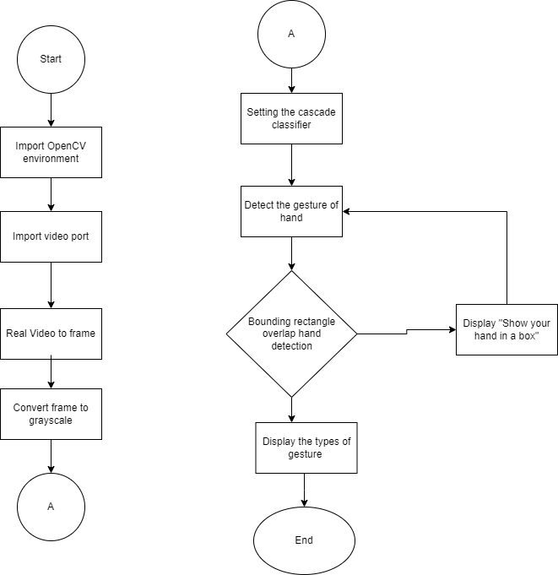

**Fig 2: Flow Chart**

# 5.GANTT CHART

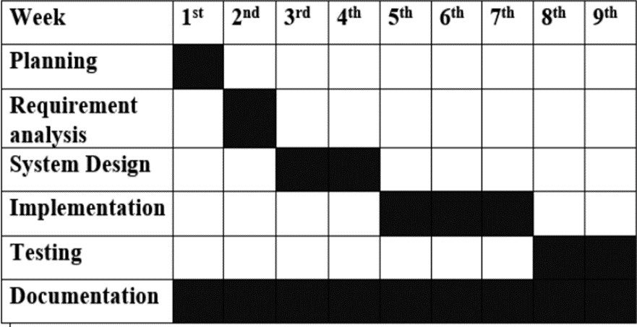

**Fig:3 Gantt Chart**

# 6. Expected Outcomes

The user will perform the hand signs, and the system will detect the sign and display it to the user.

**REFERENCES**

1. [https://medium.com/mlearning-ai/a-hand-gesture-sign-language-to-text-real-time-interpreter-usinggoogle-mediapipe-artificial-dfb395c42a23](https://medium.com/mlearning-ai/a-hand-gesture-sign-language-to-text-real-time-interpreter-using-google-mediapipe-artificial-dfb395c42a23)
2. <https://dev.to/syauqy/handsign-learn-a-sign-language-with-your-camera-2n5>